Brown pg. 1

Erik Floyd Brown

Thursday 4/2/2019

Game Deconstruction: Echo VR, (Oculus Rift)

or

Online Zero Gravity Android Ultimate Frisbee in Virtual Reality

Putting on the Oculus headset I was transported to my virtual apartment. I took a moment on my oversized leather chair to meditated against the distant sun as it burned dimly onward, oblivious to the planets rotating ever slowly into view. What to play? Today, it is Echo VR.. or more appropriately (as an April Fools prank) today it is Echo VR “Super Ultra Hyper Turbo” rebranded with 80’s neon and “Turbo” in bright yellow ala the updated cabinets to Street Fighter 2. The official page advertising straight out of the 80’s in similar fashion to the grainy high contrast saturation retrograde of Far Cry 3’s expansion: Blood Dragon.

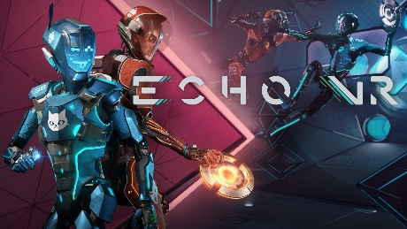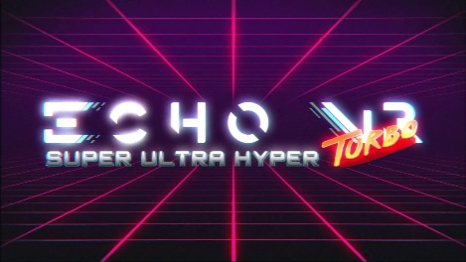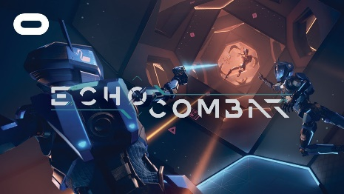

Echo VR is a competitive multiplayer online sports game developed by Ready and Dawn and published by Oculus Studios as an exclusive title for the Oculus Rift released on July 20th, 2017. While the base game is free, a combat expansion is available which I picked up for about $10.

Techno music brings me up to speed that I’m not in for a slow meander through thorny under brush and after the brief developer and publisher logo splash screens I am gifted with a simple expanse of gray chromakey presenting optimum visibility for three sets of cleanly lined menu systems: Settings, credits, legal, and quit on the left, Play and Tutorials centered under the logo splash, and Echo News and Server Status on the right. An icon bar below indicates in green arrows what peripherals are in use and their connectivity status. In my case I am using the Oculus Rift Head Mounted Display (referred to going forward as HMD), Oculus Touch controllers, and two sensors, with a medium play area. Experience may change with a 3 sensor set up, wireless HMD adapter, and larger play area.

Brown pg. 2

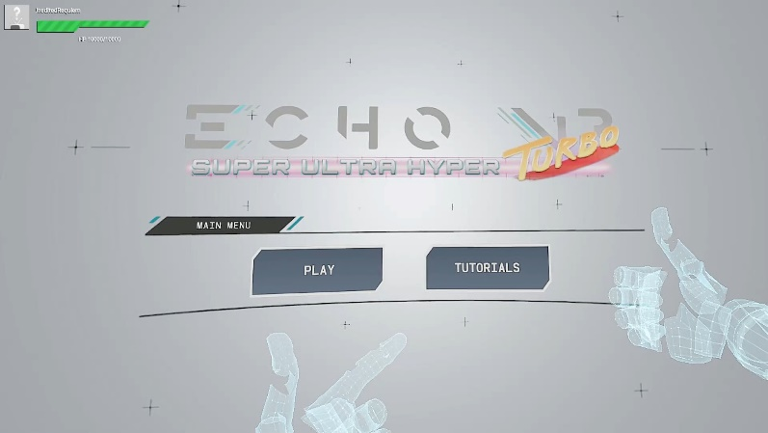

Field of view rotation is 360 degree through the HMD with options for click turning and free movement with L and R analog controlling pitch and yaw. Acceleration is designated through interaction with the Touch controllers, other playable characters, gripping the launch tube, and the player environment. Player begins at 0 speed and increases to standard trajectory through the right and left touch controllers Y and B buttons. Angle of trajectory changes with the angle of touch controllers and both accelerate to ¾ of constant speed individually over time, and to “constant” speed when utilized together.

Left analogue click allows for “thrust” and click-hold provides continual “thrust” which is slower than constant though can increase speed once at constant by an additional 50% over constant. Right analogue click brings the player to a full stop, with no reverse function. Functionally, all grabbing operations (walls, disc, objects, players characters) are done through the L and R Grip Bumper and the firing and secondary engagements are activated through the forward-facing L and R Triggers.

Players begin in a ready area and are given 15 seconds with a voiced 13 second count down to reach one of five launch tubes to assist in gathering speed to reach their selected arena. Launch tubes contain rings that when grabbed, pull the player to otherwise unattainable speeds toward the arena. Using the tandem chain technique (below) can multiply this speed resulting in potential total zone clearance and scoring. There are several different arenas each with floating stationary objects (to provide cover, grab and launch from) paths to take, and in combat settings act as “point” which provides point multipliers and better advantageous cover/map visibility. Either Echo Arena or Combat Arena Suits must be equipped (and loadout selections made/default) before each playstyle matchmaking will occur.

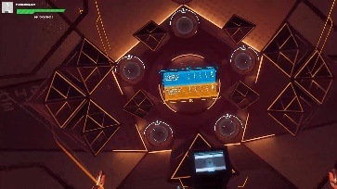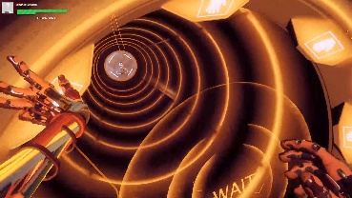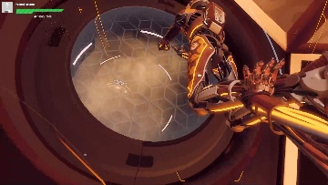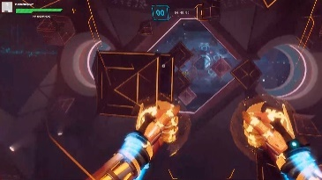

Brown pg. 3

For Player Echo Arena:

The Player Echo Arena suit has the same standard move set with the addition of an E.M.P fist made through holding L or R Bumper and Trigger together with motion controls. Use of a striking motion while charged with E.M.P disables enemy androids upon contact for 3 seconds.

For Player Combat Arena:

The Player Combat Arena suit has the same standard movement speed with an enhanced control set resulting from one selection in each of three categories (Tactical, Ordnance, and Primary) to achieve a Combat Suit player loadout. Left trigger functioning for Tac Mod, behind the head/ear Right Touch Grip Bumper for Ordnance, and Right Trigger for Primary.

Left trigger Tactical Modifiers:

Repair Matrix: Area heals of self and close by team members

Threat scanner: Scans area for hidden enemies

Energy barrier: Creates temporary wireframe riot shield that solidifies and becomes an immovable barrier allowing grabbing.

Phase shift: Darkens player, 15 second invincibility.

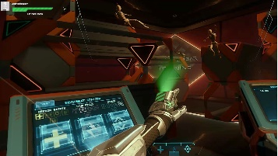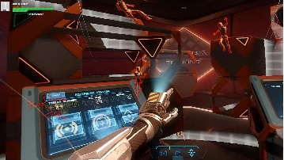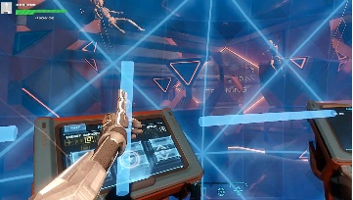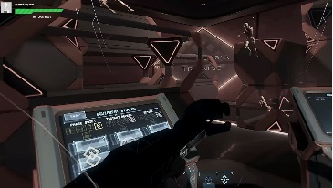

Ordnance is used with the Right Touch Grab Bumper and Motion Controls in a behind the head grab and forward release motion. Sensors loaded Ordnance from as far back and low as chin level without fail and options include:

Detonator: Throw and detonate explosive disc for area damage

Stun Field: Creates moving stun orb disabling enemy androids

Arc Mine: Throw to create barrier that stuns enemies

Instant Repair: Instantly repair self

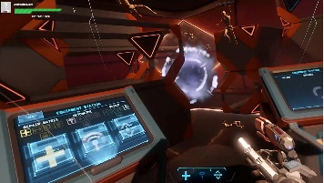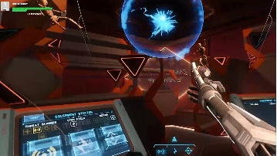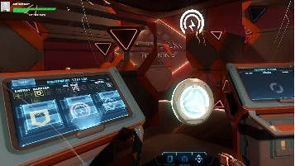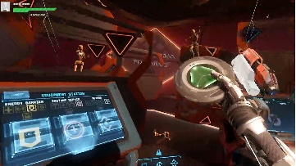

Brown pg. 4

Primary Fire is the main damage dealer aimed and fired using the Right Touch Controller and Trigger button. Primary fire causes negative acceleration with variance depending on the primary fire option.

Options include:

Pulsar -Single laser blast

Nova -Shotgun style spread shot

Comet -Chargeable rail laser

Meteor -Slow moving rocket style laser

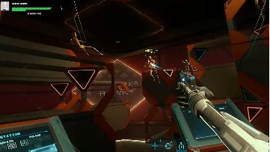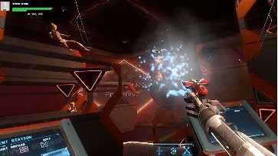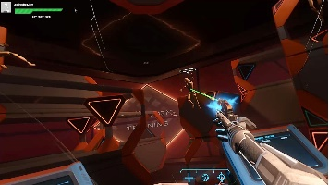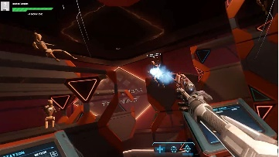

Ready at Dawn has combined both catch and release combat sports and multi loadout control schemes beautifully in a meld of form and function. In an age of games designed for controllers with a dedicated directional pad, selecting and activating secondary items comes by way of motion interaction with Touch Controllers. Opting for proxy mines, and other gear is carried in your “backpack” and is accessed by reaching behind the ear and using the grab bumper. This not only finds a functional work around it works with the style of the game, assists as a feature further immersing the player into the experience, and provides its own sense of rewarding participation. It is hard for me to imagine free flight, while catching and throwing a frisbee with one hand while simultaneously pulling a gun from my hip to fire with the other using a controller, but with motion controls it feels natural. Natural and rewarding. Make a fist and punch with E.M.P to disable a player. Grab a disc from their hands or pull yourself forward with their body, tag onto their momentum. Want to head butt? Go right ahead (and risk breaking your face or HMD). Sliding an index finger over my cyber arm to bring up a hologram containing my party/group manager? Brilliant.

Results are measure in matches, and Points are awarded regardless of victory status with increases for position on the leaderboard, successful shots, assists, and combat damage dealt. Players advance in a level-based system with customization options, skins, and emotes rewarded at different intervals. There is no presence of pay to win philosophy or Noob-tube structure in place, and all cosmetics are unlocked entirely through play.

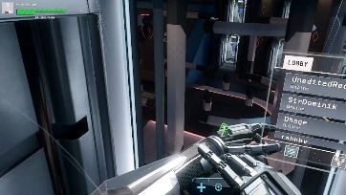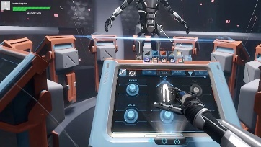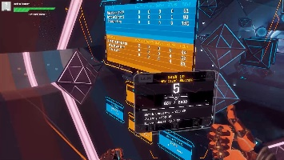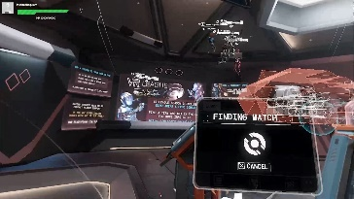

Brown pg. 5

Based entirely online and paired with players from all over the world difficulty is highly variable. Match making was generous enough to pair me with lower levels early on, however either through the hardcore dedication of VR gamers or Echo VR being popular enough to spawn competitive tournaments worldwide I quickly found myself paired with and against full squads of level 50 players. Online being what it is, those without thick skin may find being a NooB and learning from level 1 with unfiltered communications in a competitive multiplayer online game discouraging. While toxicity was readily apparent, it was limited to the select few who took up the role with great enthusiasm. The majority to players I matched with were willing to share tactics (Tandem grab chaining together at the launch tube for incremental speed increases (potentially game breaking if they could find a way to acquire the disk), and using quick wrist flips instead of full arm movements for nearly unblockable disc speeds) and were largely encouraging of team participation.

For those wanting to learn the ropes without the trial by fire, tutorials are available via the main menu or by simply being on active while waiting for matches on the side lines. Match making, and training tutorials are all interactive and presented as a space station with central command center (match making), leader boards, and outer pods for training, target practice, appearance customization, Brawling, and the Combat Expansion with subsequent item and weapon loadout customizations. Before and after matchmaking has begun the players can freely explore the station to flying around, chat with others via in game voice chat or engage in casual games such as playing catch, practicing game modes, and even playing darts. Not only is this a unique way to keep players engaged I found this downtime crucial to improving familiarity with the environment, controls, and to adjusting to 360 movement in VR.

While not devoid of cyber hands pointing in the wrong direction, the occasional arm through solid surfaces, and getting tangled in the hardwired HMD cables from frantic movement any physical and visual bugs were few and far between. Frame rate was stable and tested over LAN and wireless with both a desktop GTX 1080ti and laptop dedicated 1060 card. Movement is smooth, voice chat is clear and free of background noise, and positional audio is incredibly well executed. From what I experienced and directly from the word of mouth of gamers around the world this game is a must play.

